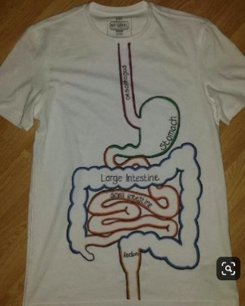
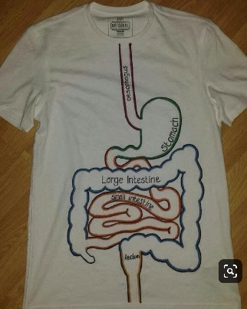
~ Digestive Design Clothing Company~

In this assignment we will dress to impress utilizing the digestive system as our point of design. First you will need to choose a partner. After a partner is chosen, you will need to acquire a white t-shirt. Feel free to create two shirts one for each partner. However, only one is required. Upon the white t-shirt you will accurately depict the digestive system from the mouth to the anus. Creativity is encouraged to design the inner portions of each organ, however make sure designs are school appropriate. The organs/structures to be included are: mouth, pharynx, esophagus, stomach, small intestine, large intestine, teeth, salivary glands, pancreas, liver, and gallbladder. The organs will need to be drawn to scale, located correctly, and labeled. The underlined organs can be placed on a sleeve or the back. In conjunction with the design, each team will be assigned a specific piece of the digestive tract to present to the class. Included in the presentation will be the location, dimensions, role, and macromolecules who are broken down, and any processes taking place in the organ. The presentation will be brief, no more than 5 minutes, minimum 2 minutes. Shirt(s) are to be worn the day of presentation. Extra credit will be given to those who create a replica of their organ.
Due dates:

April 17- MOUTH/ TEETH
April 18 – SALIVARY GLANDS/PHARYNX
April 22 – ESOPHAGUS/STOMACH
April 24 – SMALL INTESTINE/LARGE INTESTINE
April 25 – PANCREAS/LIVER
April 26 – GALLBLADDER

Scoring will be as follows (x3): 60 points (t-shirt design/presentation) + 20 points (replica)
 | 5 points | 4 points | 3 points | 2 points | 1 point
Accuracy | All structures are to scale and located correctly | 2/3 of the structures are to scale and located correctly | 1/2 of the structures are to scale and located correctly | Structures are/not to scale OR are/not located correctly | Structures are not to scale AND located correctly
Color | Each structure is color coded and design thought is implemented | 2/3 of the structures color coded and design is implemented | ½ of the structures color coded and design is thoughtful | Partial design thought and minimal color included | No color or design thought included
Presentation | All aspects are covered | Only four aspects are covered | Three aspects are covered | Two aspects are covered | One aspect covered
Time
{Deduction if needed}

