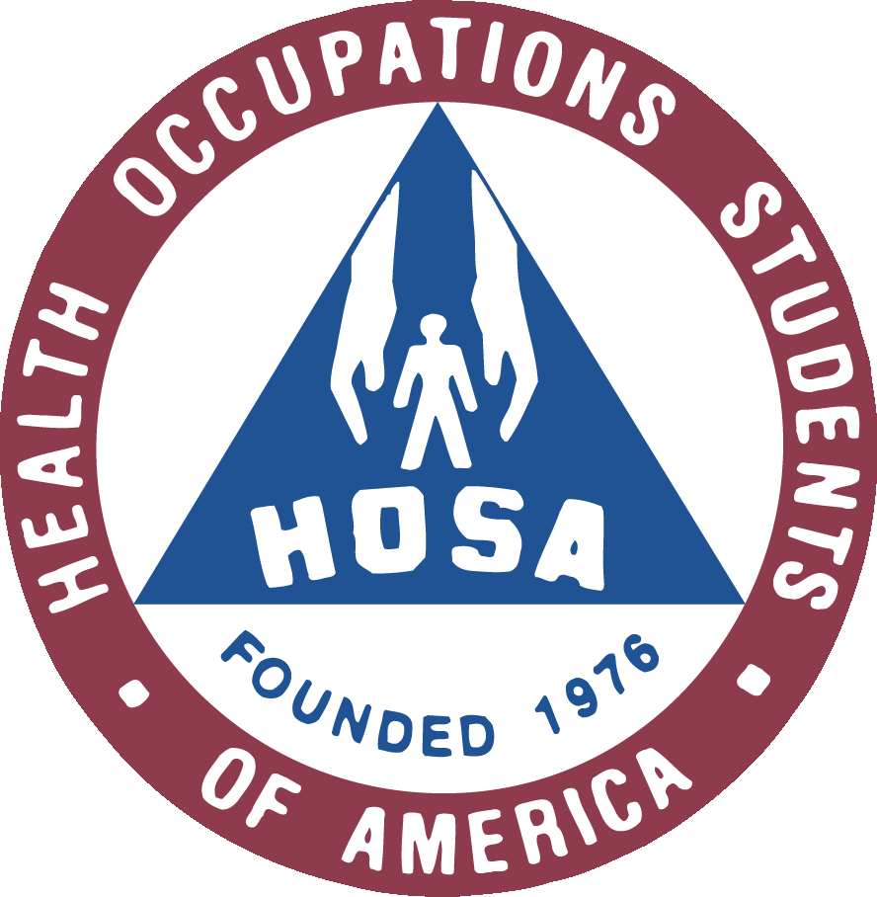

Health Science Student Manual
Dear Parents/Guardians:
Welcome to the Health Science program of RHS! My name is Mrs. Glasgow and this will be my fourth year teaching at RHS. Previous to teaching at RHS I served as a Certified Nuclear Medicine Technologist at Tennova Health Care-Clarksville. I truly value students’ excitement when they realize their potential and the potential that awaits them in the health care profession. An important part of a student’s career and professional development is the expectation that students conduct themselves during the education process in the same manner as will be expected in the employment field. Rules and procedures are an important part of life. They allow us to function in an organized and acceptable manner. In the classroom, certain procedures must be followed to maximize the student’s ability to learn. The procedures below will establish the culture for our Health Science class. Students will participate in challenging real world projects and assignments typical of the healthcare field. The classroom is a safe environment used to teach and reinforce practices that promote patient/client and staff/personal safety. Classroom activities include reading, research, projects, practical skills, and problem solving techniques.
This is a great interactive program that gives students the opportunity to join HOSA (Health Occupations Students of America), become First Aid/CPR certified, hear guest speakers from the community, etc. To learn more about what we will be studying you can access a copy of the state’s standards for the health science course your student is enrolled in at the Tennessee State Department of Education’s Career and Technical Health Science Education website: https://www.tn.gov/education/career-and-technical-education/career-clusters/cte-cluster-health-science.html
HOSA: As a student in Health Science education classes, your child is eligible to join the Health Occupations Students of America organization. This national organization focuses on preparing students for a career in the health field and is an excellent way to help students become more aware of the many career opportunities available in health care. HOSA members are also eligible to participate in regional, state, and national conferences and competitions. Membership fee is $30.00 per year which also include a t-shirt. If you would like more information concerning national HOSA you can find it at HOSA.org.

Videos: We will occasionally utilize videos/movies to illustrate different health care and health related issues. This is an excellent way to help the students understand how these issues relate to the “real world”. Because of the level of stress often seen in the healthcare environment, most of these videos are rated PG13. All videos shown relate to the standards being taught and directly correlate to the lesson. If you have any concerns regarding video content, please do not hesitate to share them with me or if you would not like your child to view these videos please email me directly.

I look forward to working with you and your student this school year. Please call or email me with any questions or concerns your may have.

Thank you for your support!

Danya Glasgow, CNMT
Phone: 553-2070 ext. 2514 7th Period Planning
Danya.Glasgow@cmcss.net
Health Science
Syllabus

COURSE: Health Science Education is an introductory course designed to prepare students to pursue careers in the fields of public health, diagnostic, nursing, emergency, and therapeutic services and exercise philology. Upon completion of this course, a student proficient in Health Science Education will be able to identify careers in these fields compare and contrast the features of healthcare systems, explain the legal and ethical ramifications of the healthcare setting and begin to perform foundational healthcare skills. This course will serve as a strong foundation for all of the Health Science programs of study.

CLASS RULES: In order for every student to learn, rules must be enforced. Any student that violates any school or class rules is subject to disciplinary actions up to and including suspension. Here is a list of our class rules.
- Be on Time!
- Stay on Task!
- Be Respectful!
- Try Hard!
- Be Prepared!
- OBSERVE ALL SCHOOL RULES AND POLICY
GRADING SCALE: Since grades are necessary to measure how well you are learning the competencies and skills presented in a given course, they are not “given” but “earned” in accordance with the following system. Grades will be comprised of homework, projects, quizzes, tests, hands-on activities and classroom participation. Weight percentage will be based upon the difficulty of the assignment.
A=93-100
B=85-92
C=75-84
D=70-74
F=1-69
Grades will be reviewed with you at least every 3 weeks. You should keep all work in your binder, chronologically! In managing your class binder this way, you should be able to calculate your ongoing grades in this class.
REQUIRED SUPPLIES
- 3 ring binder
- College rule loose leaf paper
- Notebook dividers
- Headphones or ear buds
- Color pencils
- Mechanical pencils
- Glue stick
- Scrubs (optional but for extra credit)

Class Procedures
EXTRA CREDIT: Wearing scrubs is voluntary in this class. You will receive 5 extra credit points when you wear scrubs. You must come to class already dressed in scrubs both scrub top and bottoms. You will not be permitted to leave class to change at the beginning of class or at the end. There will also be other opportunity’s to earn extra credit throughout the year that will be announced in class.

ENTERING THE CLASSROOM: You should be in your seat when the bell rings. Purses are to be kept in the area at the front of the room or under your desk, not on the table in front of you or in your lap. Hoodies, jackets, etc. should be hung on the back of your chair. They are not to be kept in your lap, or on the table. If there is an assignment on the board, begin on it immediately.

END-OF-PERIOD CLASS DISMISSAL: You should remain in your seat until the bell rings, unless instructed by teacher otherwise. The area around you should be free of trash. Absolutely, no congregating by the door prior to the bell ringing.
Leaving the Classroom Clean is a necessity that all students must take responsibility. Books and trash are not to be left on the floor.
LECTURES & CLASS DISCUSSIONS: Lecture notes should always be taken. All students should respectfully remain quiet and listen whenever someone else is speaking. If you have a question or comment, raise your hand and wait to be recognized. At no time is sleeping or the appearance of sleeping (head on table) acceptable. Other unacceptable activities are primping of any sort, i.e. applying make up, combing/braiding hair, applying/removing nail polish, etc. Any item(s) used to distract or disturb anyone in this class will be confiscated and handled as deemed appropriate per instructor.

COMPLETING ASSIGNMENTS: Work only on Health Science in class unless you have permission from your instructor. All work should be done neatly in black/blue ink or typed on computer. No other ink colors will be accepted. Assignments should be submitted on loose-leaf paper, wide ruled with no ragged composition book edges. Assignments taking two or more pages must be stapled or in an appropriate cover if indicated. If I cannot read it, I will not grade it. You should follow rules for formal writing, including grammar, punctuation, and spelling. One point will be deducted for each error. Work that does not follow instructions or is messy will have points deducted.
MAKE-UP WORK: It will be the students’ responsibility to ask for make-up work on the first day of return to school before the class starts. The work must be completed at the convenience for the teacher and in an equal number of days as the student’s absence i.e., if the student misses 3 days of class, then he/she will have 3 days to make up the assignment. Late work may be submitted with a reduction of 10% s a day. After 5 days, late work will no longer be accepted. Projects and presentations will be due upon return to school since these assignments will have firm deadlines that will have been posted way in advance. Due dates for excused absences will be per school board policy and can be discussed with the instructor when the student returns to school.
WHEN YOU ARE ABSENT: It is your responsibility to obtain, complete, and turn in any make-up work. I will not pursue you to complete your work. If you are absent, you must request your work from your instructor. I suggest partnering with another student to obtain missed notes taken during your absence. You will make an arrangement with your instructor to set up a date for your make-up test. If you fail to come on the mutually agreed upon morning, you will receive a zero. NO make-up tests will be given during class.

INSTRUCTOR’S ABSENCE: If for some reason your instructor is not in the classroom, follow all classroom procedures as stated. You should start the assignment on the board or review the previous day’s lesson. If I am absent from school, all procedures and rules are the same. All work should be turned in to the substitute.

SCHOOLWIDE ANNOUNCEMENTS: You must remain quiet when announcements are being made. This information is important. Please be respectful of the Flag and your fellow classmates during the Pledge of Allegiance and Moment of Silence.

LEAVING THE CLASSROOM: Submitting notes to the office and any other “errands” must be taken care of before school or between classes. You should use the restroom between classes. You will be given five Errand Passes to be used during the entire semester*. For example, if you need to go to Guidance or to your locker during class time, this will require use of a pass. A visit to the restroom will require the use of a pass. These five passes should more than cover any “emergencies” that may require you to leave the classroom. Any passes remaining unused at the end of the semester will earn 5 BONUS POINTS on a test grade. However, if you have 5 or more unexcused absences then bonus points will not be awarded. Passes will not be deducted for going to the school nurse and SRO.
LAB SAFETY
- Maintain a professional attitude and behavior.
- Respect yourself and others.
- Handle equipment with teacher permission ONLY!!
- Use Standard Precautions as appropriate (i.e. safety goggles, gloves).
- Report all accidents to teacher IMMEDIATELY, no matter how minor it may seem.
- Report damaged equipment to teacher IMMEDIATELY.
- Do not attempt to fix any non-working equipment
- Leave your laboratory area neat and clean.
- Return equipment to its proper place.
- Remain seated when the bell rings and wait for teacher’s dismissal from classroom.

HOSA MEMBERSHIPS: Active HOSA members must complete the HOSA application for membership and pay the membership fee of $30.00 per year (which includes a t-shirt). This enables a student to attend and compete in regional, state, and national conferences and competitions. Federal bylaws require any student interested in participating in conferences and competitions be an active member. HOSA members have the opportunity to attend educational field trips, but must actively participate in HOSA’s fundraiser.
FIELD TRIPS: In order to participate in field trips, your attendance, classroom behavior and academic progress must be exemplary. Field trips require an additional fee to cover bus transportation and must be paid at least one week prior to the trip.
PLAGIARISM: If you are caught cheating you will receive an automatic discipline referral along with an alternate assignment or exam to complete at the convenience of the instructor.

Information Sheet

Student Information

Name: ____________________________________________________________________

Address: ___________________________________ Home Phone: __________________

Email Address: __________________________________

Parent Contact Information
Please indicate with whom I should speak should concerns over attendance or academic progress arise.

Mother/Guardian:
Name | Day Phone (with ext.) | Email Address

Father/Guardian:
Name | Day Phone (with ext.) | Email Address

Is there anything (medical or personal information, specific areas of difficulty) that I should know in order to be a better teacher to you?

We have read and agree with the classroom policies as described in the syllabus and grading rationale/classroom expectations.

Student Signature Parent/Guardian Signature

